**Patch process and steps**

1. Initial step will be checking with Application team and take servers which needs to get patched.
2. Once they provide Server Details and Downtime, Raise change and schedule activity according to downtime.
3. Take AMI of those servers one day prior.

IMP NOTE: -

While taking AMI, always Enable “NO REBOOT ENABLE” to prevent impact on server.

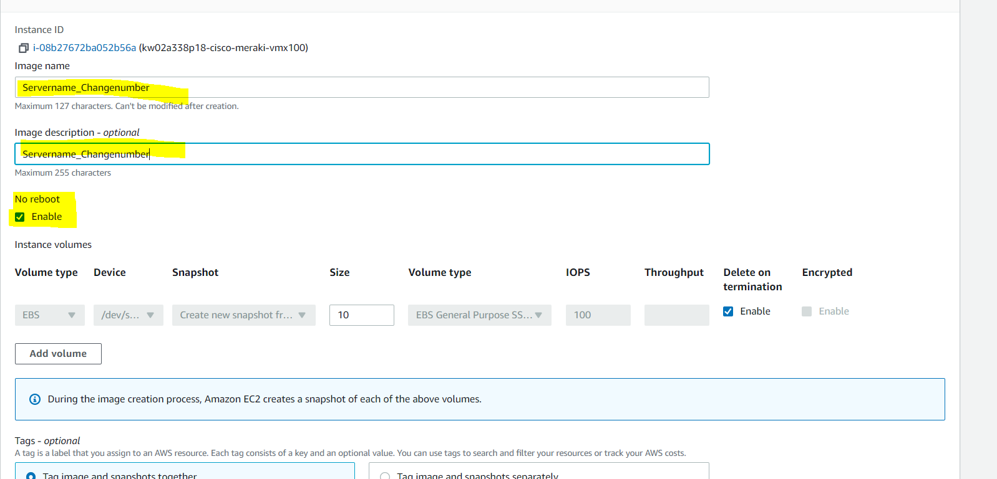

1. Perform Prechecks before activity in Scheduled window.

cat /etc/hostname

cat /etc/hosts

route -n

cat /etc/SuSE-release

cat /etc/issue

ifconfig -a

df -hT

cat /etc/fstab

uname -r && date

lsblk -a

cat /etc/resolv.conf

rpm -qa --last |head -n 35

uptime

hostname

date

uname -r

1. In AWS Console go to AWS Systems Manager in that go to patch manager,

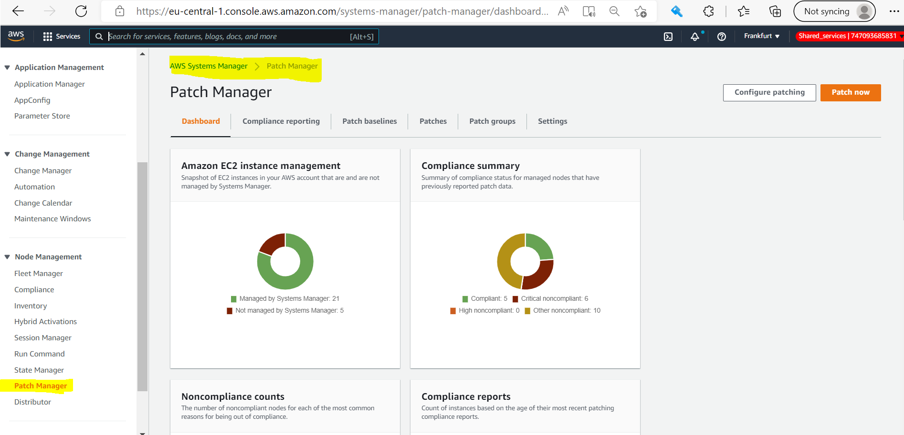

1. Go to patch baseline and edit the date

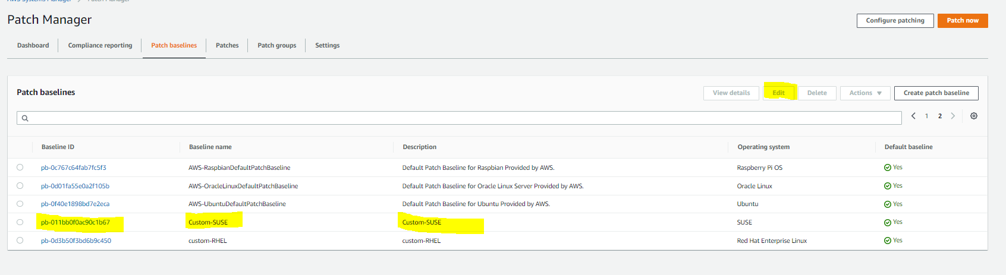

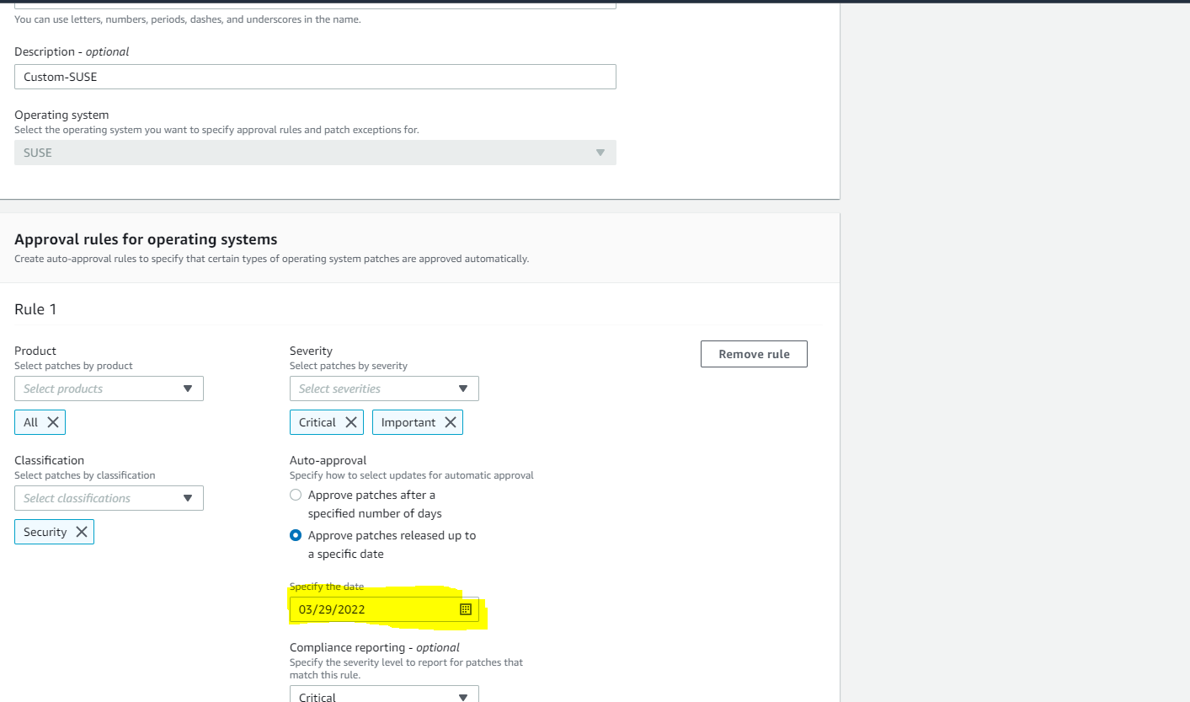

1. Go to Configure Patching and Add server names,

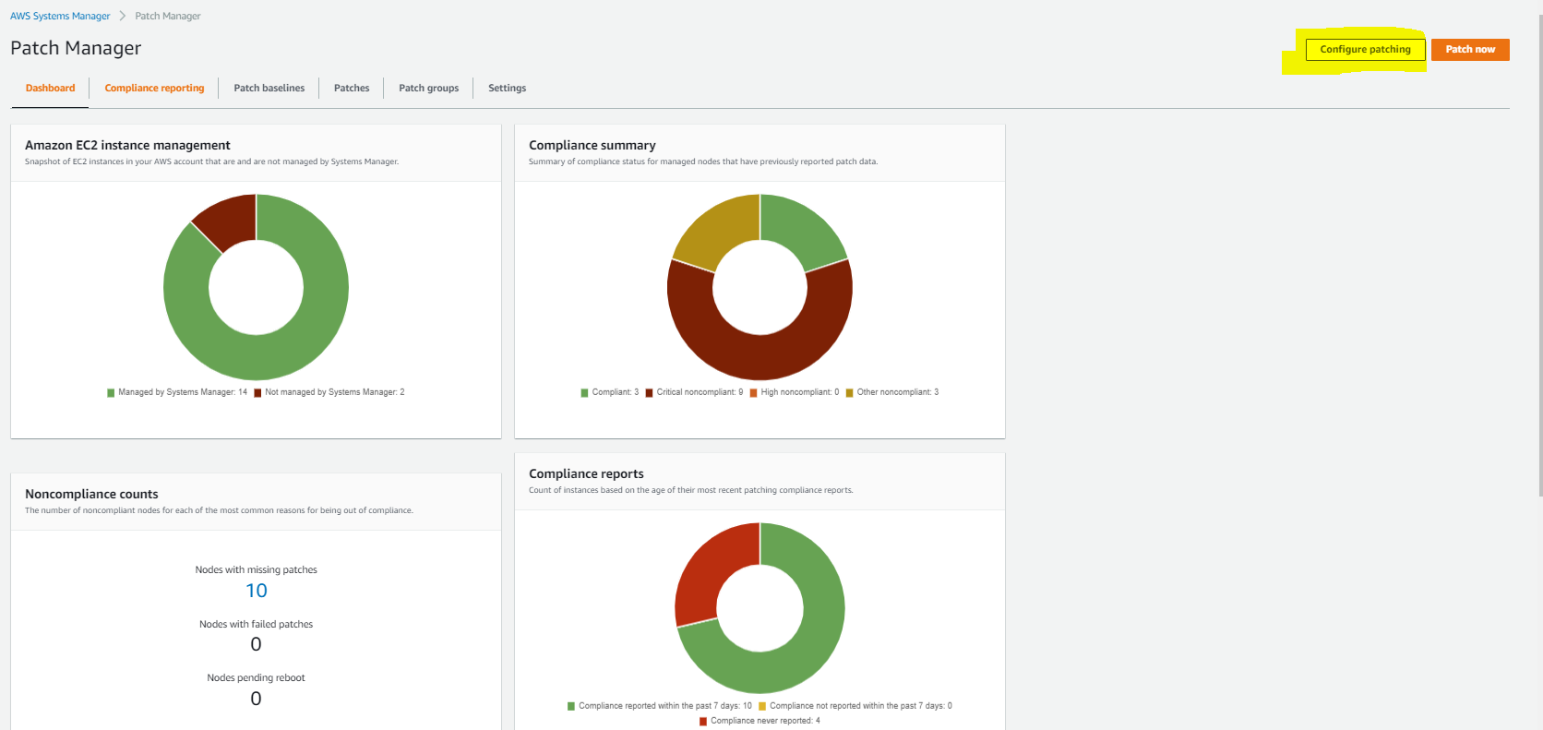

1. Add Select instance manually

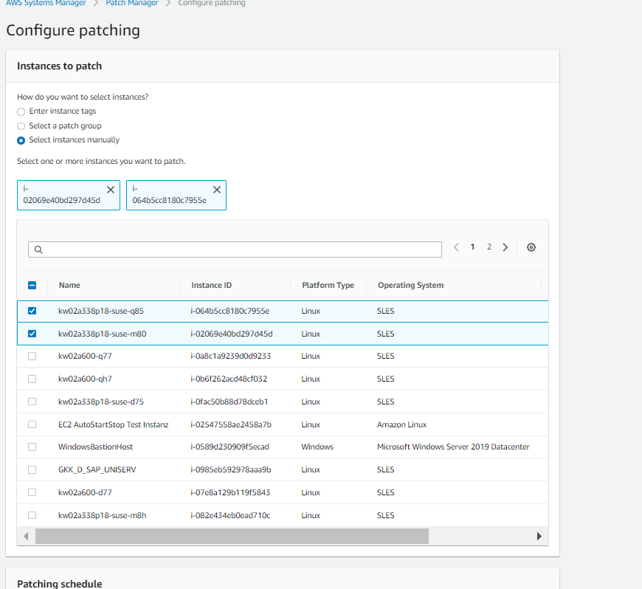

1. Select correct options, and configure patching.

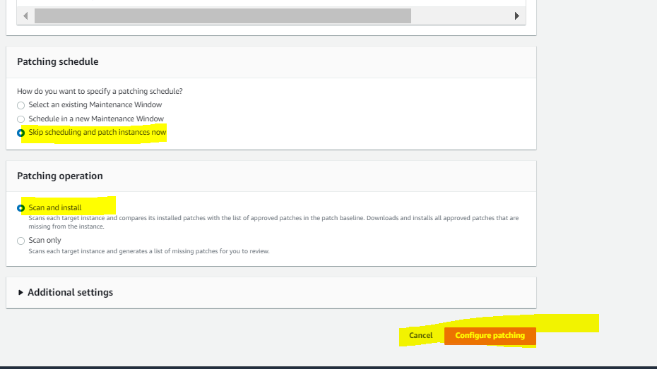

1. After patching, perform Post check. (Output of Prechecks needs to be taken)